Project 5

University of Nebraska–Lincoln
Department of Civil Engineering
Engineering Analysis II

Executive & User Summary

Team Members:
Christopher Moore

Instructor: Wissam Kontar
Section Number: 150

Due Date of Assignment: Thursday, May 7, 2026

Table of Contents
Executive Summary: 3
Module A: Aggregate Gradation 4
Module B: Volumetric Properties Calculator 6
Module C: IDEAL – CT 7
Module D: Rutting Analyzer 10
User Guide: 11
Module A – Aggregate Gradation 11
Module B – Volumetrics 12
Module C – IDEAL-CT 12
Module D – HWTT 12
Bias and Ethic in Coding: 13

Executive Summary:

The purpose of this project was to develop an automated pavement materials analysis that can process asphalt laboratory testing data. The Auto-BMD program was developed using Python and integrates four major engineering analysis modules: Aggregate Gradation, Volumetric Property Calculations, IDEAL-CT, and Hamburg Wheel Tracking Test (HWTT – Rutting Analysis).The program was designed to reduce the need for manual calculations and graph generation using procedures commonly used in asphalt mixture design and testing. Laboratory data was stored in a Excel spreadsheets, which allowed the ability to design a code that automatically imported, cleaned, processed, analyzed, and visualized through calculations and graph generation.

Module A automates aggregate gradation analysis by combining material blend percentages and generating gradation curves used for mixture evaluation. Module B calculates volumetric properties such as theoretical maximum specific gravity, bulk specific gravity, and air void content to determine whether samples satisfy design standards set by the Nebraska Department of Transportation (NDOT). Module C analyzes IDEAL-CT laboratory testing data to evaluate cracking resistance by calculating the CTIndex values using load-displacement relationships. Module D evaluates rutting performance using HWTT data by identifying rut depth, stripping inflection points, and relating them to pass/fail criteria based on defined thresholds.

Overall, the completed Auto-BMD code successfully automates multiple engineering calculations and visual aspects to support efficiency, professionalism, and organization. The information provided below demonstrates the application of Python toward a civil engineering scenario.

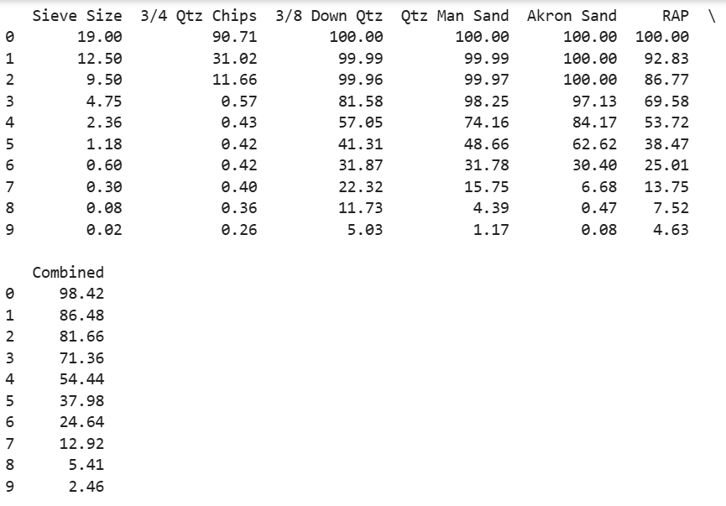
Module A: Aggregate Gradation

Figure 1. List of materials and associated gradation values.
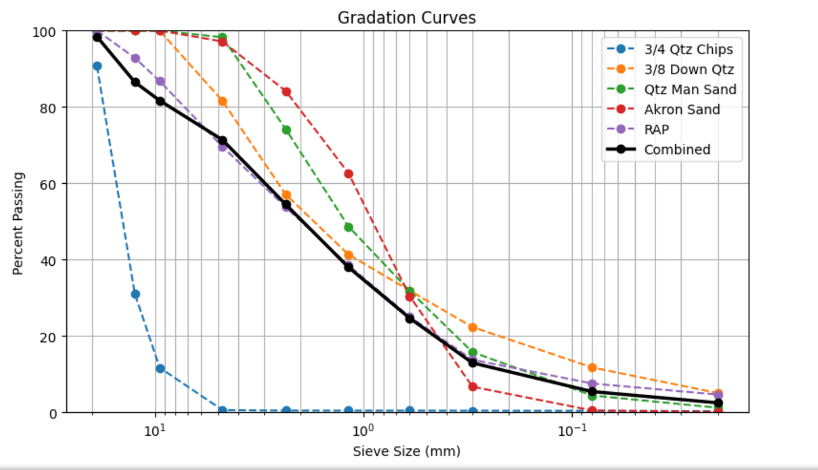
Figure 2.Gradation curves associated with Figure 1

Module B: Volumetric Properties Calculator
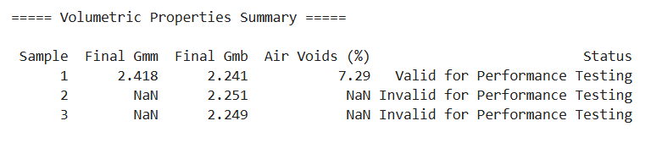
Figure 3. Volumetric Properties Summary

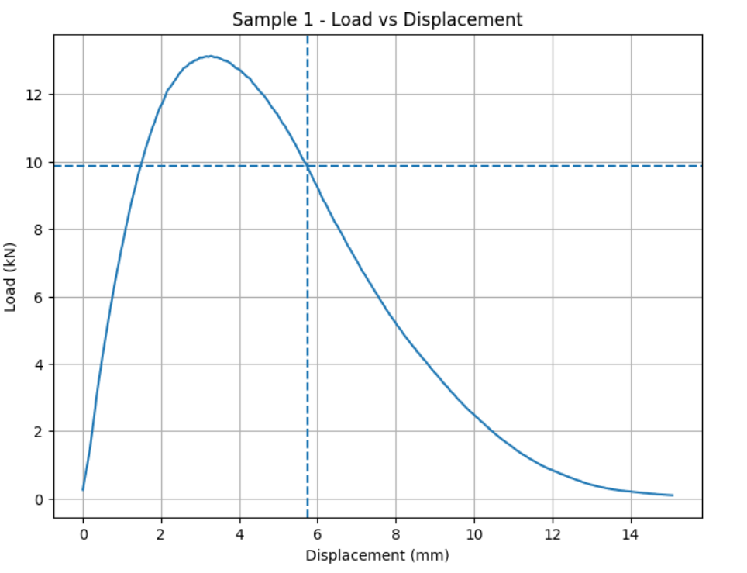
Module C: IDEAL – CT
Figure 4. Load (KN) vs. Displacement (mm)- Sample 1

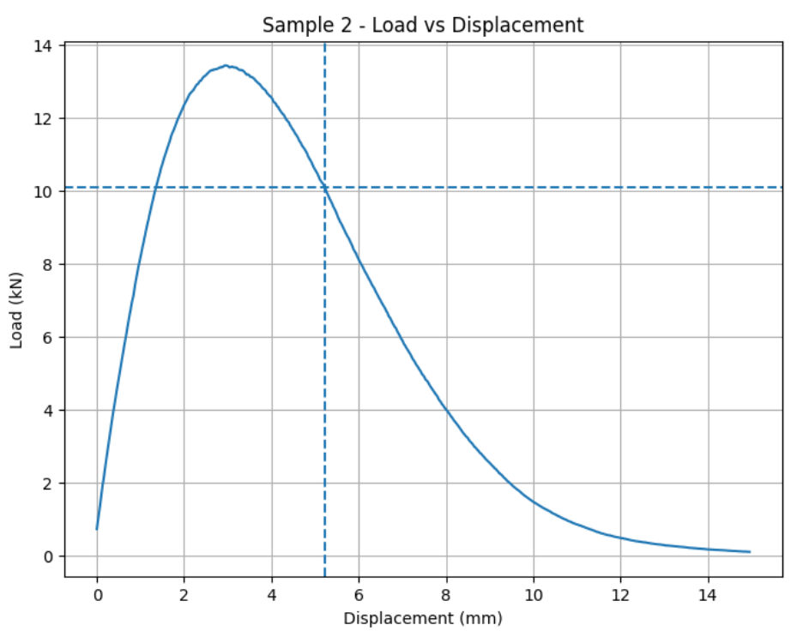
Figure 5. Load (KN) vs. Displacement (mm)- Sample 2

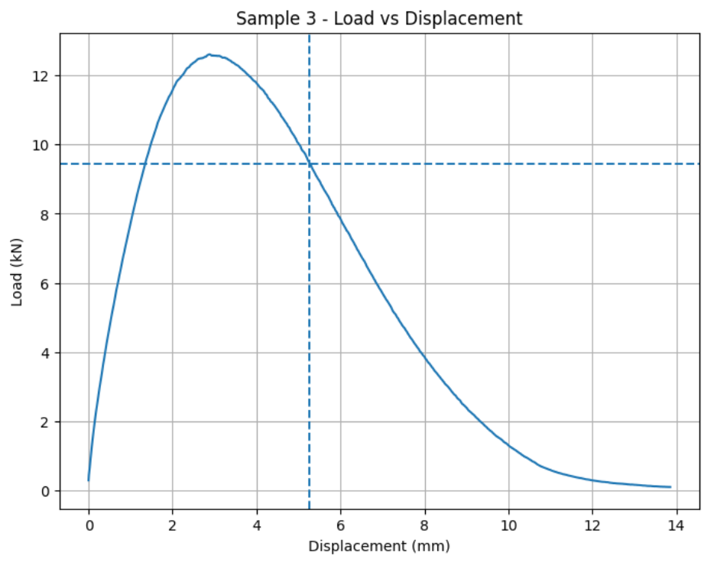
Figure 6. Load (KN) vs. Displacement (mm)- Sample 3
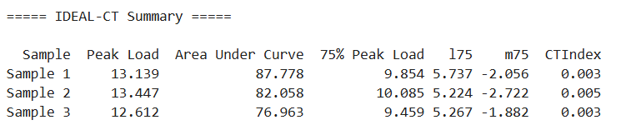

Figure 7. IDEAL – CT Summary

Module D: Rutting Analyzer
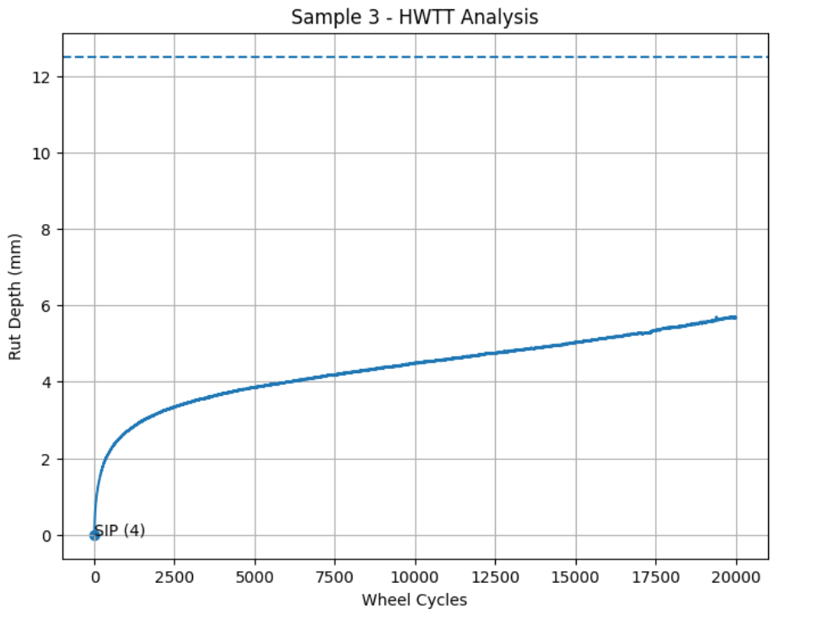
Figure 8. Rut Depth (mm) vs. Wheel Cycles

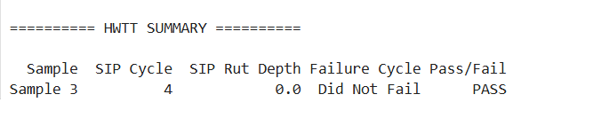
Figure 9. HWTT Summary

User Guide:

For successful use of the generated Auto-BMD program, the user must place all of the laboratory testing data like how the AutoBMD file is currently organized. Additionally, the data saved In the AutoBMD.xlsx must be stored in the same folder as the provided Python code. The AutoBMD file has four sheets within the workbook, which include Aggregate Gradation, Volumetrics, IDEAL-CT, and HWTT. Replace only the populated cells with corresponding information to ensure the code runs properly.

Module A – Aggregate Gradation
For this section of code to run, start with entering aggregate gradation data in the same cell locations as the original template. Input the sieve sizes (mm) across the designated columns. Below the sieve sizes, enter the percent passing values (%) for each defined aggregate material.
Example includes:
- 3/4 Quartz Chips
- 3/8 Down Quartz
- Quartz Manufactured Sand
- Akron Sand
- RAP
- Combined Gradation
Enter the blend percentages (%) for each material in the weight column. Values can be entered as percentages or decimals, but all included materials should use the same format as defined in the template.

Module B – Volumetrics
In the Volumetrics worksheet, enter one sample per row. Required values include:
- Sample name or ID
- Bowl mass in air (g)
- Bowl mass submerged (g)
- Bowl + mix mass in air (g)
- Bowl + mix mass submerged (g)
- Dry compacted sample mass (g)
- Submerged sample mass (g)
- SSD sample mass (g)
Note that all mass values should be entered in grams.

Module C – IDEAL-CT
In the IDEAL-CT worksheet, enter data in pairs of columns for each sample:
- Load (N or lbf)
- Displacement (mm)
Data should begin at Row 3 and continue down the sheet without blank rows. Each additional sample should follow the same two-column format.

Module D – HWTT
In the HWTT worksheet, enter data in pairs of columns for each sample:
- Wheel Cycles
- Rut Depth (mm)
Wheel cycles should increase from top to bottom, and rut depth values should match the recorded laboratory measurements.

Bias and Ethic in Coding:
During the development of the AutoBMD code, several coding decisions were made to improve automation and usability for my client. For example, excel was selected as the main input source because it is commonly used in data collection and allows engineers or interested parties to enter data into a clean formatted template.

During data cleaning, the code will automatically remove non-numeric values and skips cells with missing data to prevent calculation errors. This inclusion will help improve efficiency; it may also affect results if data is not placed correctly within the existing template. Additionally, decisions were made using mentioned engineering standards set by NDOT. For example, Module B uses NDOT air void limits of 6.5-7.5%. Beyond that, Module 4 uses a rut depth limit of 12.5 mm and a 20,000-wheel cycle threshold for a pass/fail evaluation.

